Paper Title (Each Word of the Title Should Begin
with a Capital Letter with the Exception of Articles
and Conjunctions)

Line 1 - FullName1, FullName2
Line 2 - Name of organization1
Line 3 - City1, Country1
Line 4 - Author1, Author2@domain.edu
FullName3
Name of organization2
City2, Country2
Author3@domain.edu

Abstract—The abstract describes a summary of the paper. In some cases, the authors confuse the abstract with the introduction. In the abstract using of acronyms and abbreviations is undesirable.

Introduction
In Proceedings of FRUCT conference there are two sections: Full Papers and Work in Progress. In the first section are articles having positive recall of most reviewers. In the second section will be published articles that need to be completed according to the reviewers. Also in Work in Progress are published abstracts for performances.
The article should contain the following structural components:
- Title
- Information about authors
- Abstract
- Introduction
- Main part
- Conclusion
- Acknowledgment
- References
The components are arranged in the order in which they should be in the article.
Abstracts for performances have only the first three components. All of these components will be considered in more detail.
II. Title and general rules of article (Heading 1)
- General rules (Heading 2)
1) Page size (Heading 3): The size of page should be Letter (21.59 cm × 27.94 cm).
2) Volume: For publication in the section Full Paper, beginning with the Proceedings of FRUCT, article must be at least 6 pages and no more than 12 pages. Abstracts for performances may be from 1 to 3 pages. Exceeding these volumes is only possible by prior agreement with the organizers of the conference.
3) Font: Only font Times New Roman is using in template. Another font can be used only for program listing (for example Courier New).
4) Margins: If you are using Word margins must be: top — 1.9 cm, bottom — 1.6 cm, left — 1.57 cm and right – 1.57 cm.
5) Line spacing and indent: In text line spacing must be
1 pt. Increase the line spacing is provided just before and after the title of the subsection, tables and figures. About these intervals will be discussed below. In text are using indent in the size of 0.5 cm.
B. Title page
1) Paper title: Any publication: full paper or abstract for performances begins with a header. Paper title should be as concise and reflect the content of the article. The presence of abbreviations in the title is not desirable. According to the template of submissions to the FRUCT conference, each word of the title should begin with a capital letter (with the exception of articles and conjunctions). Font used in the title – Times New Roman, 24 pt.
2) Information about authors: Please place last name after first name, declare them completely. If all the authors work in one place, their names are written with a comma (after last’s no comma) in a single column. So a number of columns are equal to number of authors working in different places. Font for authors name must be 11 pt, for all other information – 10 pt. Following declare author’s place of work (at new line, no comma in the end). Place of work it’s only general name of
company or university, without name of particular department. On the new line place city and country by comma, and on the last line – email (without word “Email”, don’t use hyperlinks). The sequence of authors – at your discretion. The order of publication in Proceedings is defined by the first author. You can see different ways to design information about authors
at Fig. 1.
3) Abstract: The abstract describes a summary of the paper. In some cases, the authors confuse the abstract with the introduction. In the abstract using of acronyms and abbreviations is undesirable. Font of the abstract is 9 pt. Also first line of every paragraph have indent 0.5 cm.
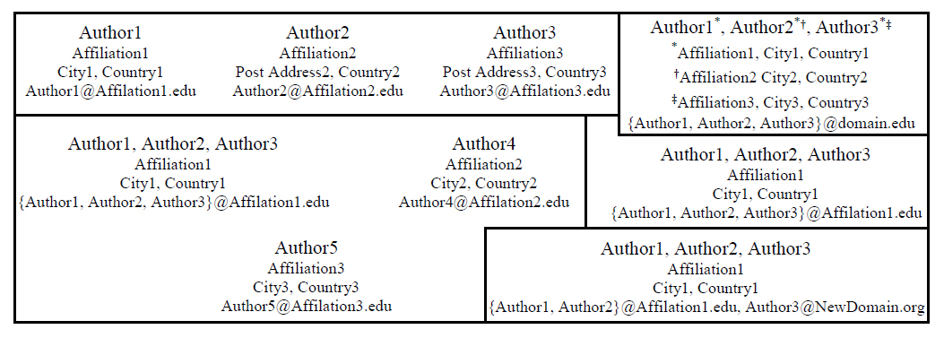
Fig. 1. Different ways to design information about authors
III. Main part
A. Title of sections
The template of conference has three levels of titles. First for section – title are numbered in Roman numerals with a point, centering, small letters must be uppercase. Space before title of first level must be 8 pt and 4 pt after it. Second level – italic, no indent, flush left, numbering of Latin capital letters. For second level the space before it must be 6 pt and 3 pt after it. The third level – italic, general indent, numbered in Arabic numerals with the bracket. At the end of subsubsection title place a colon and text of subsubsection without extra space before it. For third level there is no space before or after it. In all levels of titles only the first word is capitalized. Don’t place point at the end of titles.
B. Text in main part
Main text has indent in first line (0.5 cm). Between paragraphs should not be any extra spaces. The text is aligned to the width. Please, don’t use any hyperlinks in text. If you would like to make a cite, place it at the end of sentence before point or comma.
C. Abbreviations
The text may only use common abbreviations. Abbreviations entered by authors should be defined at first mention. It is undesirable to use abbreviations in the Abstract and
Conclusion.
D. Structural components
Consider the content of the main structural components:
1) Introduction: The introduction it is a place for description of the problem, analysis of existing solutions (with links to sources), their disadvantages and advantages of your approach. Clear statement of the work purpose is
required.
2) Main part: The main part is recommended to be divided into sections. The section titles should have meaningful names. The name ”Main part” is not allowed.
3) Conclusion: This part presents the key findings in substance. Avoid simple enumeration of the following material. It is desirable to provide a link to existing articles and grants.
4) Acknowledgment: This section is not numbered. You may wish to express gratitude here.
E. Lists
There are two types of lists: bulleted and numbered. In numbered list use right bracket after number. In bulleted list as a marker is using bullet. For text of list use indent from the left margin equal 0.5 cm. First line of each item have hanging indent equal 0.5 cm. If you start item from first word capitalized place at the end point, if not – comma (or semicolon if in text of item comma have been used). At the end of last item place point.
IV. Equation
A. Equations
In Word for equations may be using either the Times New Roman or the Symbol font (please no other font) or create
them by Math Types.
Number equations consecutively. Equation numbers, within parentheses, are to position flush right, as in (1). Equations are numbered only if they are referenced in the text. Note that the equation is centered.
where a is main symbol, b – principal and c – basic.
a - b = c | (1)
Italicize Roman symbols for quantities and variables, but not Greek symbols. Use a long dash rather than a hyphen for a minus sign. Be sure that the symbols in your equation have been defined before or immediately following the
equation.
Don’t forget to use the same style for defining symbols in the text as in equation.
B. Algorithms
If you want to lead the algorithm, design it so Algorithm 1.
Algorithm 1 Your algorithm
0: Here will be the text of your algorithm. Make operators bold, variables italic.

V. Figures and tables
Place figures and tables at the top and bottom of page. Large figures and tables may span for all page. Them can be rotated if it is necessary. Each figure or table should be caption. Insert figures and tables after they are cited in the text. Use 8 point Times New Roman for Figure and Table labels. Use words rather than symbols or abbreviations when writing labels to avoid confusing the reader. Don’t place point at the end of captions for figures or tables. Used sequentially numbered figures, tables and equations.
A. Figures
Figure captions should be below the figures and left-aligned. Use the abbreviation “Fig. 1” in text. Caption should be “Fig. 1. Caption”. Use black and white colors, example of bad black and white graphics – Fig. 2. Don’t forget to attach to the source separate files with figures. Format EPS is mandatory for TeX source.
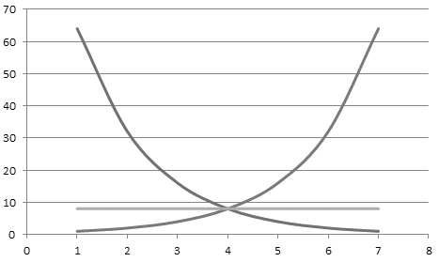
Fig. 2. Red, blue and green line
B. Tables
Table heads should appear above the tables. For table cite use “Table I”. Note that tables are numbered with Roman numerals. Table caption is “TABLE I. Caption”. The size of table caption should be 8pt. In table caption small letters must be uppercase.
VI. Design of references
The template number citations consecutively within brackets [1]. Numbering references depending on the order of their appearance in the text. The sentence punctuation follows the bracket [2]. Refer simply to the reference number, as in [3] – do not use “Ref. [3]” or “reference [3]” except at the beginning of a sentence: “Reference [3] was the first ...” Unless there are six authors or more give all authors names; do not use “et al.”. Papers that have not been published, even if they have been submitted for publication, should be cited as “unpublished” [5]. Papers that have been accepted for publication should be cited as “in press” [6]. Capitalize only the first word in a paper title, except for proper nouns and element symbols.
References must be design as a list. Use 8 point Times New Roman for References. In references there are two type of indent. First for references numbered from 1 to 9 – indent from the left margin equal 0.4 cm and hanging indent for first line equal 0.6 cm. For all other – indent from the left margin equal 0.25 cm and hanging indent for first line equal 0.75 cm. If you use TEX, please, make references as in template in main file of TEX source.
Requirements for formatting references are various depending on its type:
1) Books
- Initials and family name of each authors by comma (at last use “and”).
- Comma, name of book without quotes (italic), point at the end.
- Then all other bibliographic information by comma (publisher, year, page), point at the end.
As example [1].
2) Articles
- Initials and family name of each authors by comma.
- Comma, name of article in quotes, name of the journal or conference (italic).
- Then all other bibliographic information by comma (publisher, year, page), point at the end.
Examples for article references in [2], [3].
3) Internet resources
- Initials and family name of each authors by comma.
- Comma, name of internet resource and other bibliographic information by comma (if exists).
- Web: and web link (not hyperlink), point at the end.
Example – [4].
VII. Conclusion
I hope this article will help you to create a new article. In the end I would like to ask you, if you send your source files personally to editor, name it in accordance with the number in the system or the name of the first author.
FRUCT template developed on the basis of IEEE templates.
Acknowledgment
We would like to thank authors considerate to their articles design and reviews. Popular drawbacks for submissions of FRUCT13 are shown in the Table I. An excellent style manual for science writers is [10].
TABLE I. Popular drawbacks for submissions of FRUCT13
Drawbacks in | Number of submissions
Paper Title | 7
Information about authors | 2
Index Terms | 11
Title of sections | 9
General text | 10
Figures and tables | 15
Lists | 4
References | 13
Design do not match our template | 7
In total number of submissions | 40

References
- (Example for books) T.M.Cover and J.A. Thomas, Elements of Information Theory. New York: Wiley, 1991.
- (Example for articles) R.L. Dobrushin, “Optimum information transmission through a channel with unknown parameters”, Radiotech.Electron., vol.4, Dec.1959, pp. 1951-1956.
- (Example for articles) N.M. Blachman, “Communication as a game”, in Proc. WESCON Conf., Aug. 1957, pp. 61-66.
- (Example for web-links) IEEE official website, Manuscript Templates for Conference Proceedings, Web: http://www.ieee.org/conferences events/conferences/publishing/templates.html.
- (Example for unpublished references) K. Elissa, “Title of paper if known”, unpublished.
- (Example for references have been accepted for publication) R. Nicole, “Title of paper with only first word capitalized”, J. Name Stand. Abbrev., in press.
- M. Young, The Technical Writer’s Handbook. Mill Valley, CA: University Science, 1989.
- (For number of references) G. Eason, B. Noble, and I.N. Sneddon, “On certain integrals of Lipschitz-Hankel type involving products of Bessel functions”, Phil. Trans. Roy. Soc. London, vol. A247, pp. 529-551.
- (For number of references) C. E. Shannon, “A mathematical theory of communication”, Bell Syst. Tech. J., vol. 27, 1948, pp. 379-423.
- (For number of references) D.S. Johnson, “The NP-completeness column: an ongoing guide”, Journal of Algorithms, 9 (1988),
426-444.

